The philosophy of mathematics education

Wajeeh Daher

Reading the article "What is the philosophy of mathematics education?" by Paul Ernest

'A' or 'the':

* A philosophy of mathematics education?
* The philosophy of mathematics education?

A narrow sense of the term:

* The philosophy of some area or activity can be understood as its aims or rationale.
* So already by considering the narrow meaning of philosophy of mathematics education, the issues of the teaching and learning of mathematics, the underlying aims and rationales of this activity, the roles of the teacher, learner, and mathematics in society and the underlying values of the relevant social groups are implicated.

A system which encompasses the philosophy of mathematics education

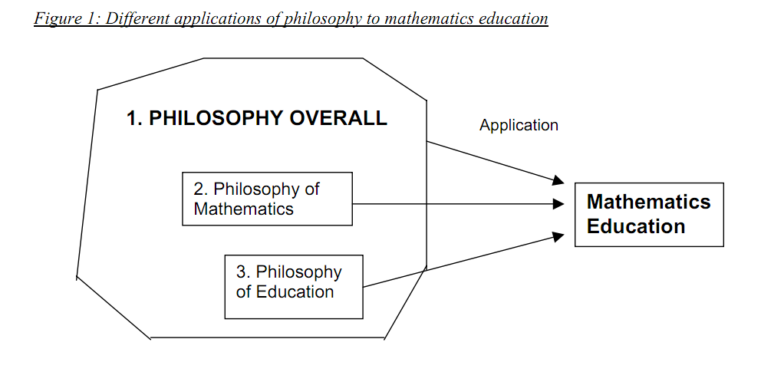

The philosophy of mathematics and mathematics education as a substantive system:

In particular, philosophy is about systematic analysis and the critical examination of fundamental problems. It involves the exercise of the mind and intellect: thought, enquiry, reasoning and its the results, judgement, conclusions and belief or beliefs. There are so many ways in which such processes as well as the substantive theories, concepts and results of past enquiry can be applied to and within mathematics education.

WHAT IS MATHEMATICS?

HOW DOES MATHEMATICS RELATE TO SOCIETY?

How do the social, cultural and historical contexts relate to mathematics, the aims of teaching, and the teaching and learning of mathematics? What values underpin different sets of aims? How does mathematics contribute to the overall goals of society and education? What is the role of the teaching and learning of mathematics in promoting or hindering social justice conceived in terms of gender, race, class, ability and critical citizenship?

WHAT IS LEARNING (MATHEMATICS)?

What is the role of the learner? What powers of the learner are or could be developed by learning mathematics? How does the identity of the learner change and develop through learning mathematics? Does learning mathematics impact on the whole person for good or for ill? How is the future mathematician and the future citizen formed through learning mathematics? How important are affective dimensions including attitudes, beliefs and values in learning mathematics? What is mathematical ability and how can it be fostered? Is mathematics accessible to all?

WHAT IS TEACHING (MATHEMATICS)?

What theories underpin the use of different information and communication technologies in teaching mathematics?

What is the role of the teacher? What range of roles is possible in the intermediary relation of the teacher between mathematics and the learner?

What are the ethical, social and epistemological boundaries to the actions of the teacher?

What mathematical knowledge does the teacher need? What impact do the teacher’s beliefs, attitudes and personal philosophies of mathematics have on practice? How should mathematics teachers be educated? What is the difference between educating, training and developing mathematics teachers?

WHAT IS THE STATUS OF MATHEMATICS EDUCATION AS KNOWLEDGE FIELD?

What standards are applied? What is the role and function of the researcher in mathematics education? What is the status of theories in mathematics education? Do we appropriate theories and concepts from other disciplines or ‘grow our own’? How have modern developments in philosophy (post-structuralism, post-modernism, Hermeneutics, semiotics, etc.) impacted on mathematics education? What is the impact of research in mathematics education on other disciplines?

**Controversies in the philosophy of mathematics education**

Philosophy of Mathematics

Foundationalists and absolutists, on the one hand, want to maintain that mathematics is certain, cumulative and untouched by social interests or developments beyond the normal patterns of historical growth. Fallibilists, humanists, relativists and social constructivists, on the other hand, have been arguing that mathematics is through and through historical and social, and that there are cultural limitations to its claims of certainty, universality and absoluteness.

Aims of mathematics education

1. Industrial Trainer aims - 'back-to-basics': numeracy and social training in obedience

(Authoritarian)

1. Technological Pragmatist aims - useful mathematics to the appropriate level and knowledge and skill certification

(industry-centered)

1. Old Humanist aims - transmission of the body of mathematical knowledge (mathematics centered),
2. Progressive Educator aims - creativity, self- realization through mathematics

(Child centered),

1. Public Educator aims - critical awareness and democratic citizenship via mathematics

(Social justice centered)

Theories of Learning Mathematics

Mathematics Teaching

Mathematical pedagogy - problem solving and investigational approaches to mathematics versus traditional, routine or expository approaches?

Technology in mathematics teaching

Mathematics and symbolization

Mathematics and culture

Research Methodologies in Mathematics Education

Absolutism:

Linking Philosophies of Mathematics and Mathematical Practice In the philosophy of mathematics there is a range of perspectives which may be termed ‘absolutist’. These view mathematics as an objective, absolute, certain and incorrigible body of knowledge, which rests on the firm foundations of deductive logic. Among twentieth century perspectives in the philosophy of mathematics, Logicism, Formalism, and to some extent Intuitionism, may be said to be absolutist in this way (Ernest 1991, 1998).

Thus according to absolutism mathematical knowledge is timeless, although we may discover new theories and truths to add; it is superhuman and ahistorical, for the history of mathematics is irrelevant to the nature and justification of mathematical knowledge; it is pure isolated knowledge, which happens to be useful because of its universal validity; it is value-free and culture-free, for the same reason.

Thus although it exceeds its intended scope, absolutism suggests a philosophically sanctioned image of mathematics as rigid, fixed, logical, absolute, inhuman, cold, objective, pure, abstract, remote and ultra-rational.

An absolutist-like view may be communicated in school by giving students mainly unrelated routine mathematical tasks which involve the application of learnt procedures, and by stressing that every task has a unique, fixed and objectively right answer, coupled with disapproval and criticism of any failure to achieve this answer.

Fallibilism:

In the past few decades a new wave of ‘fallibilist’ philosophies of mathematics has been gaining ground, and these propose a different and opposing image of mathematics as human, corrigible, historical and changing (Davis and Hersh 1980, Ernest 1994b, Lakatos, 1976, Tymoczko 1986). Fallibilism views mathematics as the outcome of social processes.

Mathematical knowledge is understood to be eternally open to revision, both in terms of its proofs and its concepts. Consequently this view embraces the practices of mathematicians, its history and applications, the place of mathematics in human culture, including issues of values and education as legitimate philosophical concerns. The fallibilist view does not reject the role of logic and structure in mathematics, just the notion that there is a unique, fixed and permanently enduring hierarchical structure. Instead it accepts the view that mathematics is made up of many overlapping structures which, over the course of history, grow, dissolve, and then grow anew, like trees in a forest (Steen 1988).